Key Instant Recall Facts
Year 4 – Summer 2

I can multiply and divide 1 and 2-digit numbers by 10 and 100.

By the end of this half term, children should know how to multiply and divide by 10 or 100 mentally. The aim is for them to recall these facts instantly.

When you multiply by  10, the digits move one place to the left.  4 x 10 = 40  7 x 10 = 70  53 x 10 = 530  72 x 10 = 720 | When you multiply by  100, the digits move two places to the left.  3 x 100 = 300  9 x 100 = 900  25 x 100 = 2500  16 x 10 = 1600 | When you divide by 10, the digits move one  place to the right.  5 ÷ 10 = 0.5  9 ÷ 10 = 0.9  35 ÷ 10 = 3.5  72 ÷ 10 = 7.2 | When you divide by  100, the digits move two places to the right.  2 ÷ 100 = 0.02  8 ÷ 100 = 0.08  29 ÷ 100 = 0.29  99 ÷ 100 = 0.99
Key vocabulary

Ten times bigger Ten times smaller Hundred times bigger Hundred times smaller
Move the digits one place to the left Decimal point tenths hundredths

Children should be able to work these out in their heads.
They should also be able to say answers such as 5 ÷ 10 = 0.5 as 5 tenths and 29 ÷ 100 = 0.29 as 29 hundredths or 2 tenths and 9 hundredths.
Top Tips
The secret to success is practising little and often. Use time wisely. Can you practise these KIRFs while walking to school or during a car journey? You don’t need to practise them all at once: perhaps you could have a fact of the day.
Play games - Make your own dominoes with calculations on one side and the answers on the other side.
http://www.snappymaths.com/multiplication/multby10or100/multby10or100.htm https://www.bbc.com/bitesize/articles/z2fkwxs

Key Instant Recall Facts
Year 4 – Summer 1

I can recognise decimal equivalents of the fractions ½, ¼, ¾, tenths and hundredths.

By the end of this half term, children should know the following facts. The aim is for them to recall these facts instantly.
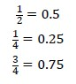 | 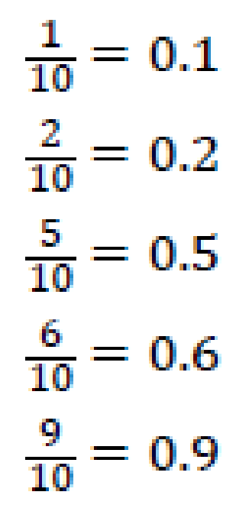 | 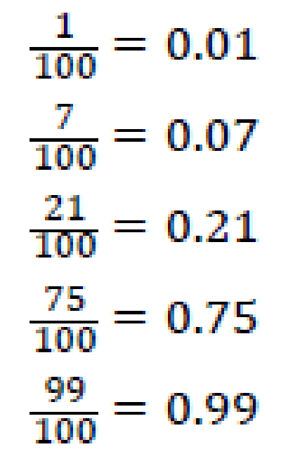 | Key vocabulary  How many tenths is 0.8?  How many hundredths is 0.12?  Write 0.75 as a fraction?  Write ¼ as a decimal?

Children should be able to convert between decimals and fractions for ½, ¼, ¾ and any number of tenths and hundredths.
Top Tips
The secret to success is practising little and often. Use time wisely. Can you practise these KIRFs while walking to school or during a car journey? You don’t need to practise them all at once: perhaps you could have a fact of the day.
Play games - Make some cards with pairs of equivalent fractions and decimals. Use these to play the memory game or snap. Or make your own dominoes with fractions on one side and decimals on the other.
https://www.topmarks.co.uk/maths-games/daily10 - Level 4 – Fractions – decimal equivalents

